October 21, 2020

Notice of Symposia on Workforce Housing
Joint Legislative Council
Senator Roger Roth and Representative Robert Brooks, Co-Chairs
Wednesday, October 28, 2020
2:00 p.m.
The Symposia Series on Workforce Housing will present information on the current state of workforce housing in Wisconsin and survey how other states have incentivized or reduced barriers to the development of affordable workforce housing.
- Experts from the National Conference of State Legislatures (NCSL) will provide an overview of the variety of other states’ policy initiatives related to workforce housing.
Interested parties may live stream the symposia session on YouTube at the following link: https://youtu.be/7MisOmmey3g.

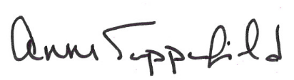
Anne Sappenfield, Director
Legislative Council
AS:ksm
*A quorum of the Senate Committee on Utilities and Housing or the Assembly Committee on Housing and Real Estate may be in attendance at any or all of the symposia. Any actions of these committees will be limited to information gathering.

